**Exercise No:4**

**Date:15/10/2020**

**Aim:** Write a Python program (function) to print a single string from two set of strings received from user and swap the first two characters of each string..

**Program:**

**def swap(a,b):**

**if(len(a)>1 and len(b)>1):**

**x=b[:2]+a[2:]**

**y=a[:2]+b[2:]**

**print(x+' '+y)**

**else:**

**print("Invalid")**

**a=input().strip()**

**b=input().strip()**

**swap(a,b)**

**Link:**

[**http://103.53.53.18/mod/vpl/forms/edit.php?id=234&userid=1782**](http://103.53.53.18/mod/vpl/forms/edit.php?id=234&userid=1782)

**Output:**

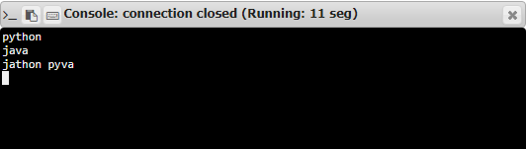

**Result:**

The program was executed successfully and the output was verified.